Manda Boyce~ 207.266.9293

[TwirlHoops@gmail.com](mailto:TwirlHoops@gmail.com)

[www.TwirlHoops.com](http://www.TwirlHoops.com)

www.Facebook.com/TwirlHoops

Get Fit-

Stay Fit

Have FUN doing it!!!

## What if you could *workout with your* friends... outside...

## at an affordable price...

## in your neighborhood? Contact us to bring a Twirl Hoop workout to your neighborhood.

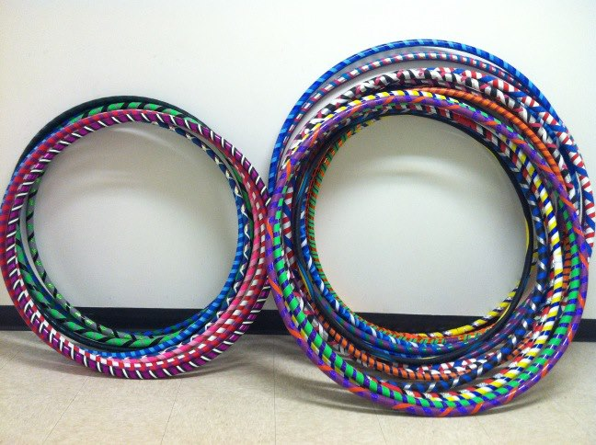

# Twirl Hoops

## Why Hooping??

* Excellent head-to-toe workout
* Strengthens and tones your core
* Sculpts your waistline
* Tones and defines arms and shoulders
* Speeds weight loss
* Low impact cardio workout
* Increases your metabolism
* Energizes your body and spirit
* Practiced any time of year
* Relieves Stress
* Develops balance and coordination
* Enhances and encourages creativity
* Enjoyed by all ages
* No Experience Necessary
* **Burn 500 to 700 calories per hour!!**

Hooping is a new fitness trend that uses larger weighted hoops. The larger hoops spin much easier than common toy hoops. The added weight of the hoop provides a workout challenge which instantly torches more calories than most cardio workouts.

Hooping truly makes you feel like a kid again. It is a great way to leave behind the chaos of day to day life while getting a great workout!

Twirl Hoops is locally owned and operated out of Clinton, Maine and owned by Maine native Manda Boyce. Manda started hooping in August of 2012 and immediately fell in love. She started Twirl Hoops to share her passion for hooping with everyone around her. Manda makes custom hoops that are built for your particular shape and hooping ability. She also teaches Twirl Fit, Power Twirl and hoop dance classes. Classes are available for group and personal instruction, special events, parties and fundraisers. Hoops are always provided and available for sale at all classes.

Hooping is a great way to get and stay fit, laugh, learn, be creative, and just have fun.

All hooping classes are open to all skill levels. Children are welcome to most classes with adult supervision. Whether you have never even picked up a hoop or you are a regular hoop dancer, Twirl Hoops is for you!!

**All classes are one hour in length and include a warm up and cool down.**

**Group Instruction:**

**Each Class $10 or buy a pass and SAVE**

**5 Classes for $45**

**10 Classes for $80**

**All passes expire 90 days from purchase.**

**Please check out website, call, email or check out our Facebook page for a full listing of ongoing classes. All classes are available on a one pass basis or buy more for a discount!!**

**Private Classes ages 13 and up:  
Private Instruction: $60.   
Two People: $80.  
Small Group (up to 6): $100**

**Children ages 12 and under:**

**Private Instruction: $50**

**Two Children: $75**

**Small Group (up to 6):$120**

**Parties with 6+:$250**

**Call for fundraising ideas.**

Twirl Hoops are very different from hoops in Toy Stores... Twirl Hoops are high quality, durable, and made for adults. They are weighted and a bit heavier than a child's hoop. This helps with using the momentum of the hoop to revolve around your body and to perform tricks with ease..

**Large 42" hoops** have a slower rotation and are easier to start. Recommended for taller, larger or less experienced hoopers. $30

* **Medium 39" hoops** are the most versatile. Great for beginners and intermediate hoopers. $30
* **Small 36" hoops** have a faster rotation and are better for a cardio workout. Recommended for children, hoopers under 4'6", or advanced hoop dancers & performers. $20

**Collapsible Customization** is standard on most adult hoops.

All hoops ship for $10 shipping and handling.

Gift Certificates Available

Give a gift certificate for a private lesson!

Large hoops ($40.00): (36 - 42" diameter, 160 psi)

* Hoops better sized for beginners or for slower, fluid hooping.

## Pricing



## About Twirl Hoops