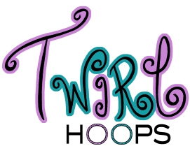
Jk
Fundraising Opportunity
Manda Boyce- Owner/ Instructor
207.266.9293
TwirlHoops@gmail.com
wwwTwirlHoops.com
www.Facebook.com/TwirlHoops

- Great for:
  - Mission Trips
  - School Teams
  - Adoption Fees
  - Dance Studios
  - Sorority Houses
  - Cheering Squads
  - Medical Expenses
  - School Supplies
  - Charitable Contributions
    - AND SO MUCH MORE!!!

- Fundraiser formats that work well include:
  - Classes
  - Hoop-A-Thons
  - Contests
  - Selling hoops ($40 adult and $30 child. $10 from each sale goes towards the event)
  - Donation admission hoop dances

